|  |  |
| --- | --- |
| **NAME** | M. Arslan Ahmad, M. Basit, Abdul Mateen |
| **REG NO** | 2020-EE-409, 401, 399 |

**LAB No 03**

**SSB & DSB Modulation and Demodulation**

**Objective:**

* To study about the modulation and demodulation using SSB and DSB
* Making Simulink circuits of both SSB and DSB

**Single-Sideband Modulation:**

In [radio](https://en.wikipedia.org/wiki/Radio) communications, **single-sideband modulation** (**SSB**) or **single-sideband suppressed-carrier modulation** (**SSB-SC**) is a type of [modulation](https://en.wikipedia.org/wiki/Modulation) used to transmit information, such as an [audio signal](https://en.wikipedia.org/wiki/Audio_signal), by [radio waves](https://en.wikipedia.org/wiki/Radio_wave).

A refinement of [amplitude modulation](https://en.wikipedia.org/wiki/Amplitude_modulation), it uses [transmitter](https://en.wikipedia.org/wiki/Transmitter) [power](https://en.wikipedia.org/wiki/Electric_power) and [bandwidth](https://en.wikipedia.org/wiki/Bandwidth_(signal_processing)) more efficiently. Amplitude modulation produces an output signal the bandwidth of which is twice the maximum frequency of the original [baseband](https://en.wikipedia.org/wiki/Baseband) signal.

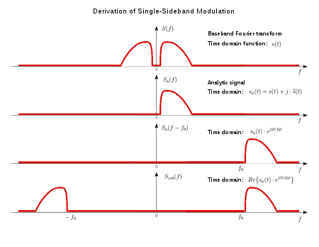

**Double-Sideband Modulation:**

Double-sideband suppressed-carrier (DSB-SC) modulation is **an amplitude modulation that consists only of the two symmetrical sidebands and no carrier band**. I came across this scheme in an ultrasound application, where power utilization can be maximized when all power is available on the sidebands.

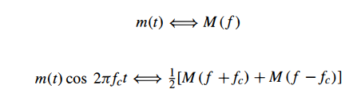

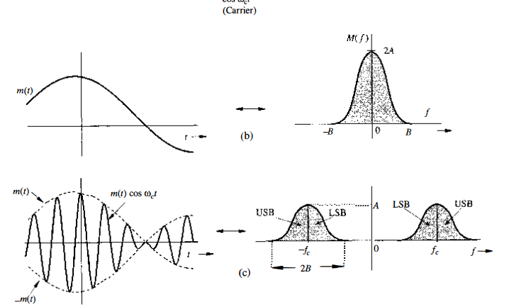

**Demodulation:**

The AM modulation translates or shifts the frequency spectrum to the left and the right by fc. To recover the original signal m(t) from the modulated signal, it is necessary to retranslate the spectrum to its original position. The process of recovering the signal from the modulated signal (retranslating the spectrum to its original position) is referred to as demodulation.

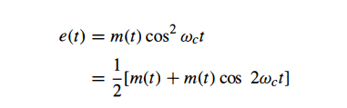

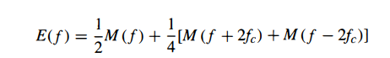

**TASK-1: DSB Modulation and Demodulation:**

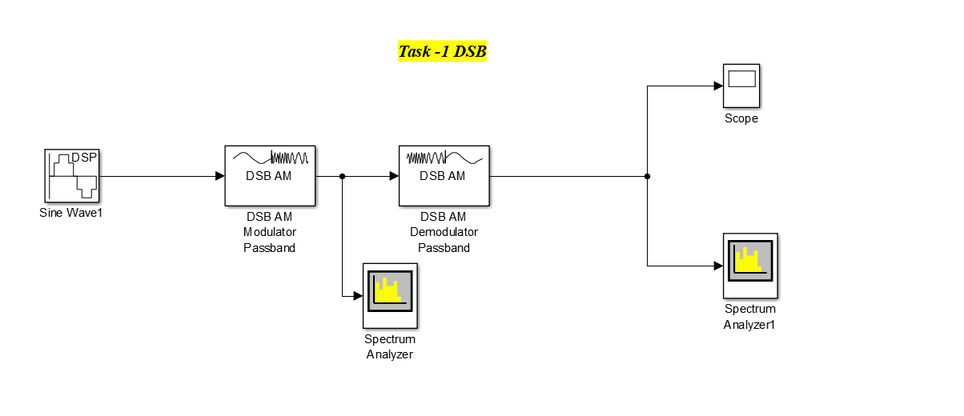**Block-Diagram:**

**Figure 1(DSB Block Diagram using Simulink)**

**Figure 2(DSB Modulated Signal at fc=400Hz)**

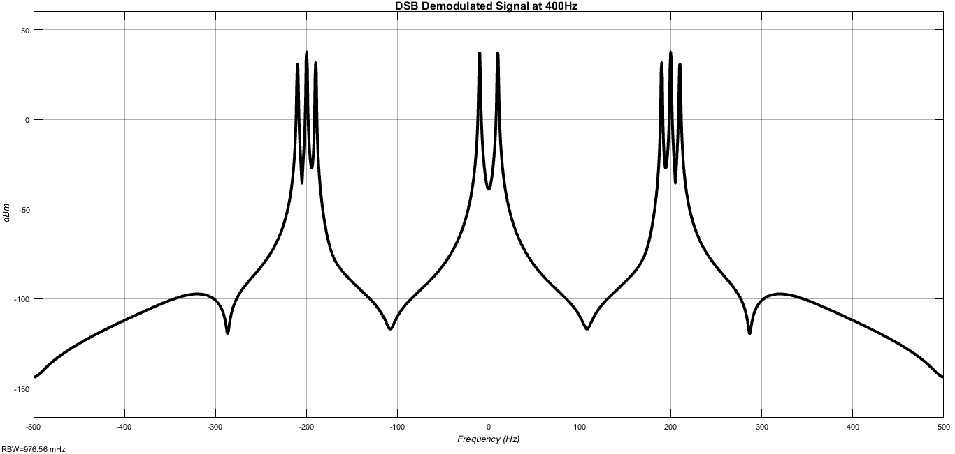

**Figure 3((DSB Demodulated Signal at fc=400Hz)**

**Figure 4(DSB Demodulated Time Domain Signal at fc=2000Hz)**

**Figure 5(DSB Final Demodulated Signal at fc=2000Hz)**

**Task-2 SSB Modulation and Demodulation:**

**Block-Diagram:**

**Figure 6(SSB Simulink Block Diagram)**

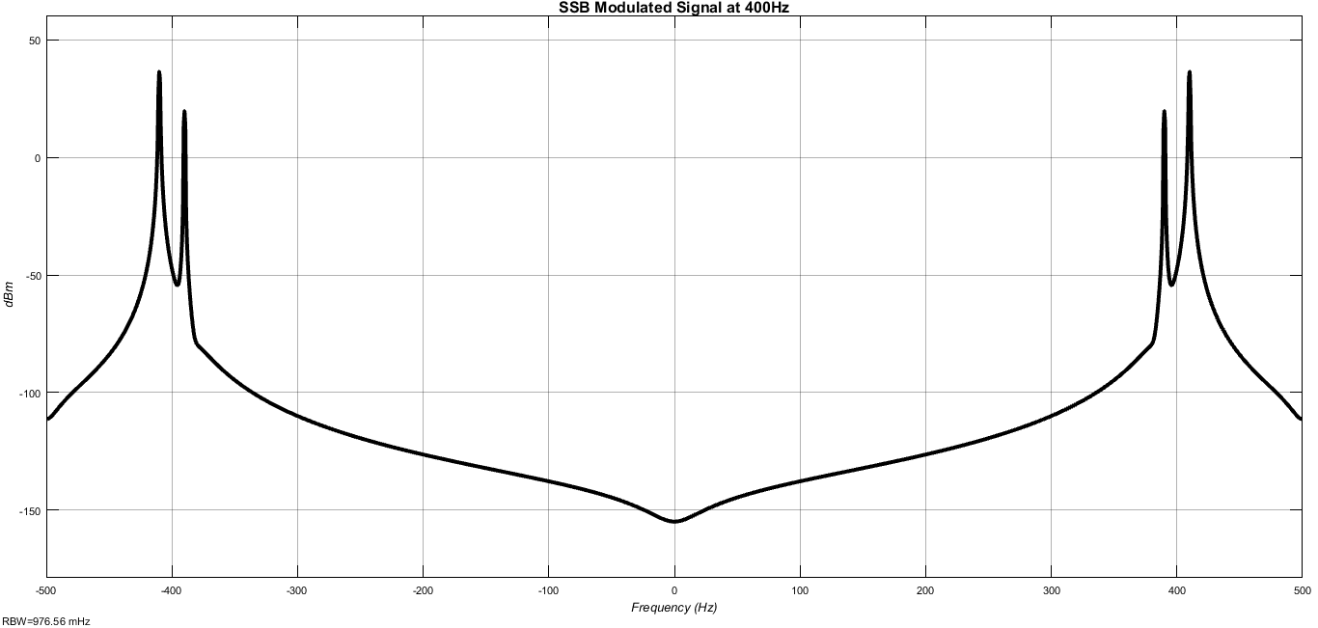

**Figure 7(SSB Modulated Signal at fc=400Hz)**

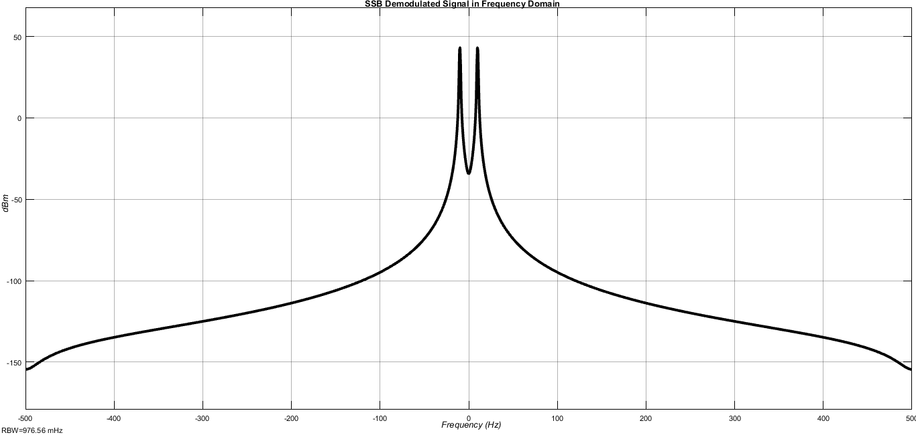

**Figure 8(Final Demodulated Signal at fc=2000Hz)**

**Figure 9(SSB Demodulated signal at fc=400Hz)**

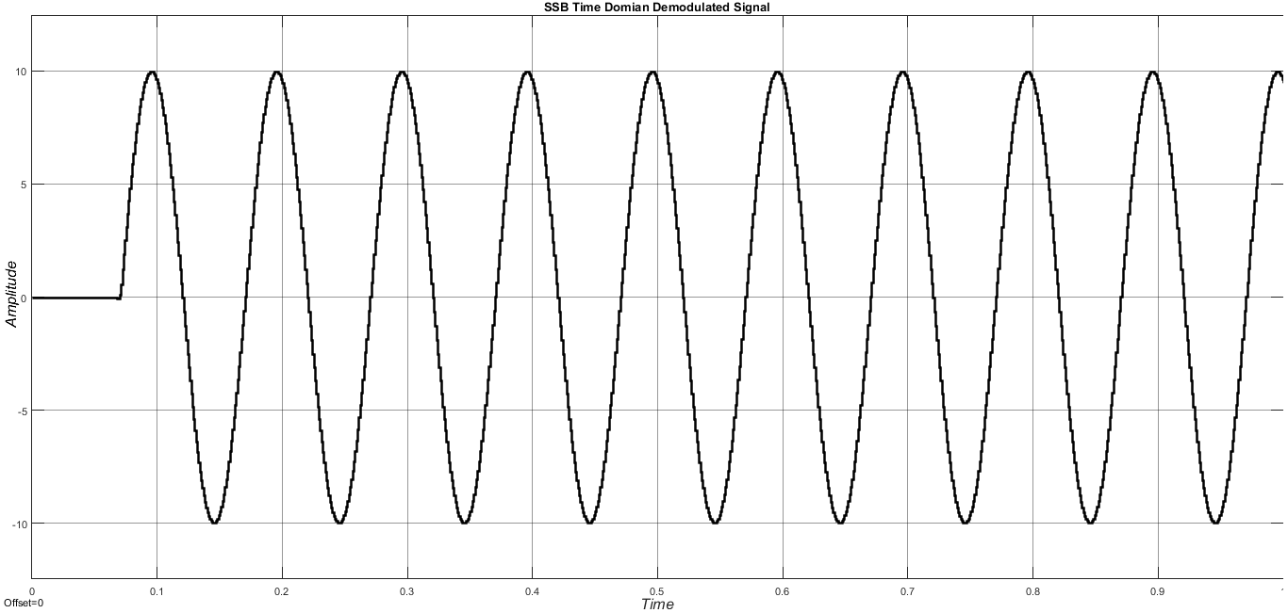

**Figure 10(DSB Time domain Demodulated signal at fc=2000Hz)**

**Conclusion:**